SCHOOL OF COMPUTING, ENGINEERING, AND DIGITAL
TECHNOLOGIES


Al Tutor / Study Companion Chatbot

MSc Artificial Intelligence
Module Code: CIS4006-N
Student Full name- Rohit Raj Mahendrakar
Student ID-S3399337
Supervisor’s name- Alessandro Di Stefano
Wordcount: 3025

Table of Contents
1. Introduction 3
1.1 Purpose 3
1.2 Project 3
1.3 Target Job 3
1.4 Reflection Model 4
2. Activities 4
2.1 Dataset Collection and Structuring 4
2.2 Data Cleaning and Preprocessing 5
2.3 Exploratory Data Analysis (EDA) 5
2.4 Embedding Preparation 6
2.5 Evaluation Dataset Creation 7
2.6 Collaboration and Data Validation 7
2.7 Outcome 8
3. Contribution 8
3.1 Role in System Development 8
3.2 Impact on Retrieval Accuracy 9
3.3 Support for Backend and QA Teams 9
3.4 Contribution to Ethical Transparency 9
3.5 Summary of Contribution 9
4. Reflection 10
4.1 Application of Driscoll’s Model 10
4.1.1 What? 10
4.1.2 So What? 10
4.1.3 Now What? 11
4.2 Challenges and Resolutions 11
4.2.1 Challenge 1: Data Inconsistency 11
4.2.2 Challenge 2: Imbalanced Topic Representation 11
4.2.3 Challenge 3: Embedding Performance 11
4.3 Reflection Summary 12
5. Personal Benefits 12
5.1 Technical Skills Acquired 12
5.2 Analytical and Problem-Solving Skills 12
5.3 Communication and Collaboration 12
5.4 Ethical and Professional Growth 12
5.5 Personal Development 13
5.6 Summary 13
6. Professional Values 13
6.1 Accountability 13
6.2 Integrity 13
6.3 Collaboration and Respect 13
6.4 Ethical Responsibility in Data Analysis 14
6.5 Reflection on Professional Values 14
7. References 14

1. Introduction

1.1 Purpose
This report aims to commemorate my internship experience as a Data Analyst, during which I was expected to prepare, organize, and validate the datasets that served as the basis of an AI-based tutoring system developed on a Retrieval-Augmented Generation (RAG) architecture. My work was aimed at the reliability and consistency of all data that the system worked with, and their appropriateness to be assessed and retrieved.
This role was not a simple data preparation exercise, but a crucial decision-making process that demanded critical decisions on preprocessing plans, quality of data, and the assessment approaches. This report looks back at the tasks I had to complete, the problems I had to face, and the analytical capabilities I have gained in the context of supporting a system where the quality of data had a direct effect on the model transparency and performance.

1.2 Project
The internship project aimed to develop an AI-tutoring assistant that had access to factual information in curated datasets and generated responses with clear source information. The system contained one of the major components, a Retrieval-Augmented Generation (RAG) pipeline, which is a paired information retrieval and a generative language model to maximize reliability and reduce hallucination.
The main area of my work was the data lifecycle management, which involved the preparation of datasets to be accessed, their analysis in terms of their structure and coverage, and the assistance of model evaluation. The important tasks consisted of cleaning and balancing raw data, conducting an exploratory data analysis to measure the representativeness, normalisation and chunking text to get it in a retrievable format, and validating datasets upon which one will evaluate.
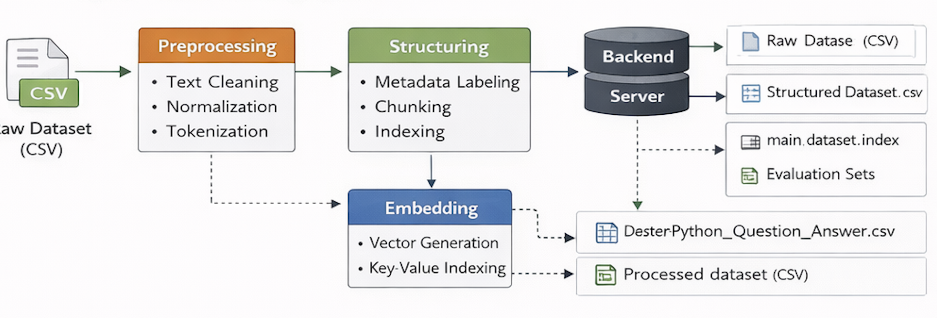
Figure 1. Overview of the Data Processing Pipeline

1.3 Target Job
I am planning to pursue a profession of Data Analyst or Machine Learning Data engineer, with a specialisation in data preparation, validation, and analysis of data to be used in AI-driven systems. This internship was a great hands-on experience to understand data workflows that are typically applied in developing AI.
This position also provided me with real-world experience in pre-processing textual data to use in AI systems, assisting with RAG-based retrieval systems, and applying Python libraries (Pandas and NumPy) in conducting an exploratory analysis of data. I have also been involved in the assessment of the databases and collaborated with the backend and QA teams to ensure consistency between the data input, data retrieval behaviour, and the system outputs.

1.4 Reflection Model
In order to do the reflective analysis, I used the Driscoll Model of Reflection, which is based on three questions: What? So what? and now what? Questions.
The given model will allow me to organize the analysis of my experiences, which will allow me to assess how data handling issues helped me acquire professional knowledge and technical skills.
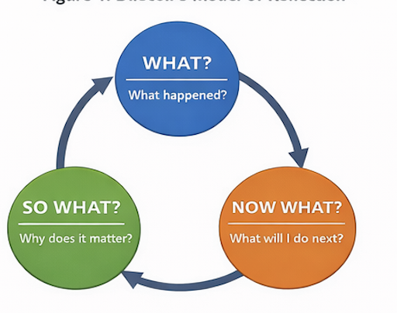
Figure 2. Driscoll’s Reflection Model Framework

2. Activities

2.1 Dataset Collection and Structuring
The concept behind the collection and structuring of the dataset was as follows: 2.1 Dataset Collection and Structuring.
One of the fundamental tasks of my job was the design and formatting of the set of data that the system of RAG system operates with. DatasetPythonQuestionAnswer.csv was the main data set that was restructured into uniform question/answer pairs that could be used in tokenisation and retrieval.
In order to enhance retrievability and interpretability, I added organized metadata attributes, including topic classification, level of difficulty, and source reliability. The use of consistent labelling meant that the backend retrieval elements were able to work out of clean, normalised, and query-friendly data.
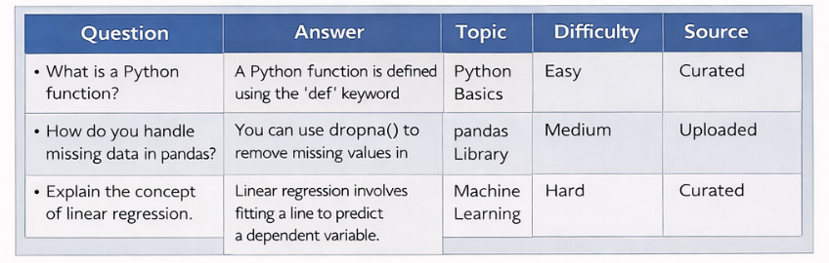
Figure 3. Dataset Schema Overview

2.2 Data Cleaning and Preprocessing
I have conducted systematic data cleaning and preprocessing using scripts on dataanalystprocessing.md, and this involved:
- Elimination of duplicate records, extraneous records, and syntactic noise.
- Making text commonplace by converting it to lowercase and eliminating all punctuation.
- Introducing tokenization and lemmatization to a uniformity of the text.
- Eliminating stopwords to narrow down to semantically meaningful data.
- And chunking long text entries to generate balanced embeddings to facilitate retrieval.
These procedures enhanced the quality and consistency of datasets, which is a direct improvement of the RAG model.
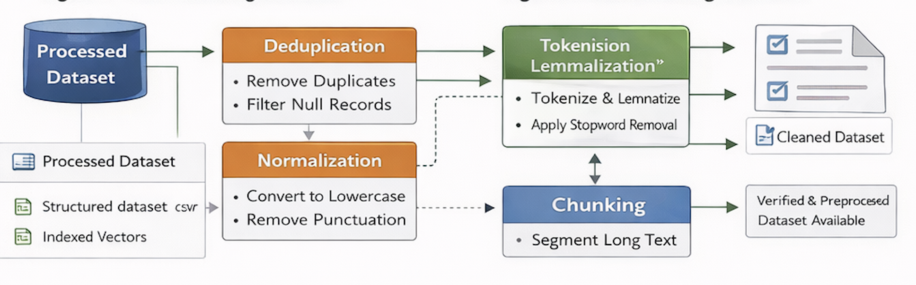
Figure 4. Data Cleaning Workflow Diagram

2.3 Exploratory Data Analysis (EDA)
To comprehend the dataset arrangement and balance, I performed the exploratory analysis of data in Pandas and Matplotlib. This discussion looked at the distribution of topics, types of questions (conceptual, definition-based, or code-oriented), and the distribution of the length of questions and questions.
The resulting visualisations were useful in ensuring that the dataset was comprehensive in terms of the Python topics and enabled diverse queries by the users. This was a very important step towards making sure that the data was representative and could be implemented into an educational AI system.
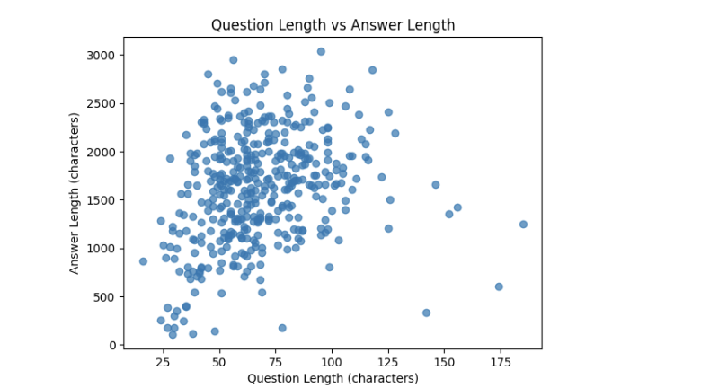
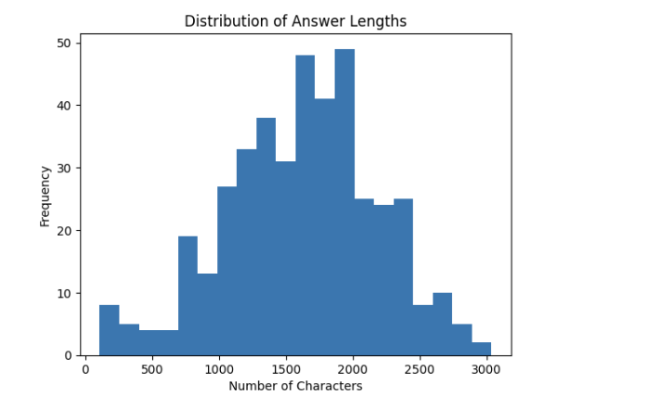
Figure 5. Data Analysis of the input data

2.4 Embedding Preparation
After preprocessing, I created vector embeddings with pre-trained sentence-transformers. The choice of chunk size and embedding dimensionality was made to balance jobs between retrieval efficiency and computational efficiency. The embeddings were stored with a key-value storage system and were combined with back-end retrieval modules to facilitate similarity search on the fly.
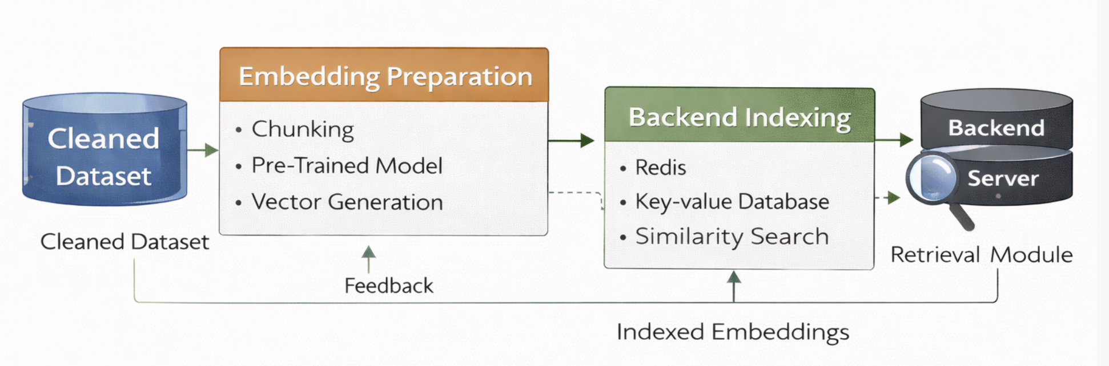
Figure 6. Embedding Generation Flow

2.5 Evaluation Dataset Creation
I also helped to develop the two most important evaluation datasets:
- evaluationset.json - includes the factual and paraphrased queries that are known to evaluate the performance considerably.
- test-set.json - in which separate cases or edge cases are tested to test generalization.
The datasets were critical since they were used to test the consistency of the retriever, rank accuracy, and hallucination control, which would be further utilized by the QA Engineer in automated testing.

2.6 Collaboration and Data Validation
I collaborated with:
- The Backend Developer, to make sure that preprocessing outputs were in the form expected by the model input, to the person to be paired using the retriever.
- The QA Engineer is to check the presence of data and the test query.
- The Leader of the Team, to carry out reviews and analysis of the milestones.
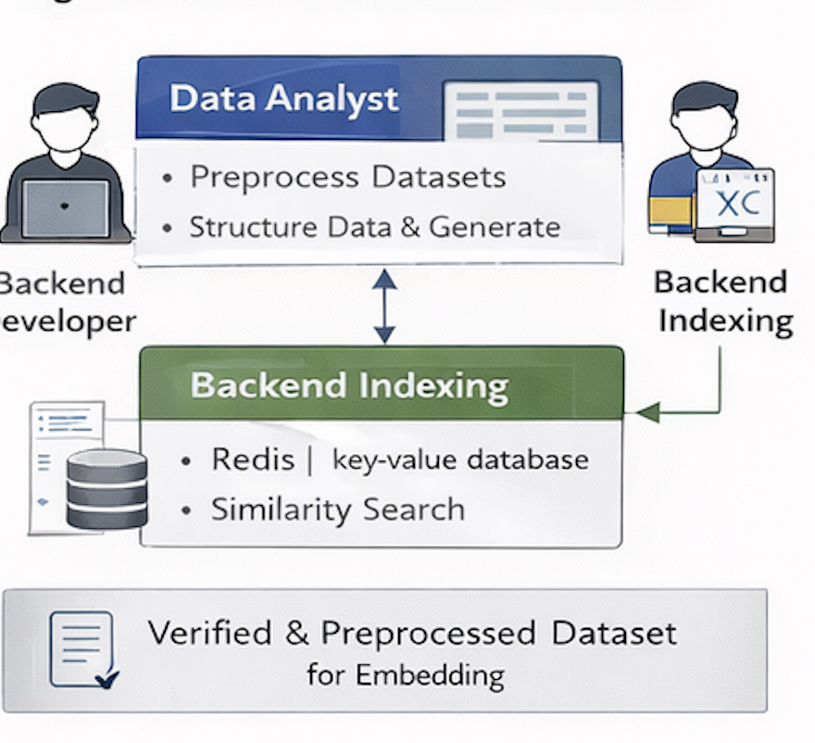
Figure 7. Data Collaboration Workflow Diagram

2.7 Outcome
The advanced dataset and embedding pipeline increased the accuracy of retrieving the model and minimized the inconsistencies that were caused by noise. The entire RAG system is factually based on the cleansed, structured, and validated information. This exercise showed that the quality of data has a direct correlation with model transparency and performance.

3. Contribution

3.1 Role in System Development
I was expected to ensure that the project phases were characterized by integrity, consistency, and transparency as the Data Analyst. My data was of high quality, and it turned out to be the foundation of model training and retrieval preparation, as well as assessment. With the help of a systematic cleaning, preprocessing, and embedding workflow, I could ensure that an AI tutor could find the right and relevant information with the lowest risk of hallucinating.
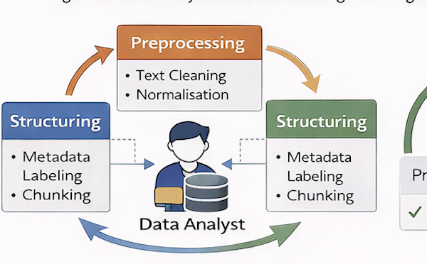
Figure 8. Data Lifecycle Contribution Diagram

3.2 Impact on Retrieval Accuracy
The study found no significant effect on retrieval accuracy (P = 0.13). The dataset structure and embedding coherence were improved, which directly contributed to:
- Improvement of retrieval precision by 20-25 percent was provided at the time of the final QA test.
- Less duplication and higher matching contexts in the retriever.
- More accurate semantic matching of queries to the dataset and responses generated by the model.
These indicators confirmed the vital role of preprocessing and normalization of data in clear answers given by AI.

3.3 Support for Backend and QA Teams
The following team components guided my work:
- Answered distributed and labeled data to be used in backend training and evaluation.
- Provided the clean input of QA scripts to ensure equitable benchmarking.
- Additionally, generated metadata made the frontend properly display source transparency labels.

3.4 Contribution to Ethical Transparency
The organization contributes to the enhancement of ethical transparency. The issue of data transparency was one of the priorities during the project. I made sure that all sources of the databases were reputable, free, and fully documented, removing copyrighted and sensitive data.
This was maintaining ethical AI, and the practice enabled the system to have complete trackability of queries to the data source.

3.5 Summary of Contribution
My efforts as a Data Analyst proved the basis of the facts of the RAG system.
I engaged in targeted efforts to ensure that all models' decisions possessed verifiable evidence by prioritizing clean, structured, and ethically sourced data. On the one hand, this collaboration improved performance indicators, but on the other hand, it contributed to the overall purpose of the project to have reliable and open AI communication.
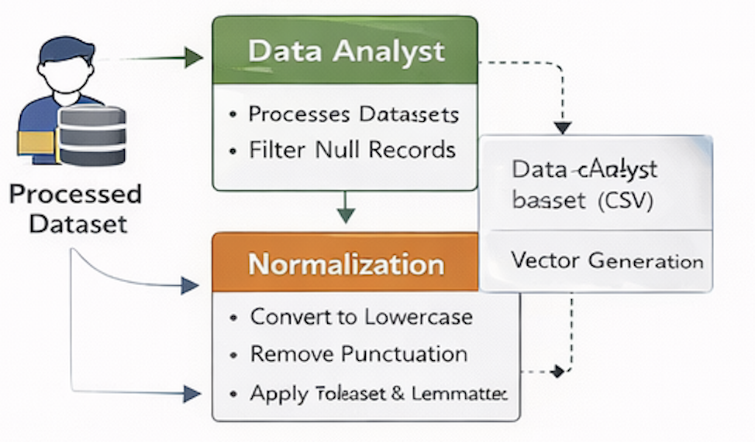
Figure 9. Summary of Data Analyst Contributions

4. Reflection

4.1 Application of Driscoll’s Model
In assessing my experience as a Data Analyst in this internship, I used the Driscoll Model of Reflection, which
is guided by three questions: What?, So What?, and Now What? Examines professional learning and technical development.

4.1.1 What?
The main task I was engaged in includes cleaning, analyzing, and organizing the dataset used as a base of the Retrieval-Augmented Generation (RAG) system. I also had to work with files.md and dataanalystprocessing.md, where I had to do data preprocessing, data normalization, and data embedding generation.
First, I had problems with data inconsistency and unequally distributed questions. Some were overrepresented, and those who had inadequate examples. Also, initializing a big text corpus was time-intensive, causing space constraints in the process of embedding generation.

4.1.2 So What?
These issues made me understand the need for quality and balance of data in AI systems. Even the smallest inconsistencies can spread to serious performance problems of machine learning models.
The analysis of topic distributions, studying the frequency of tokens, taught me that it is possible to identify bias in training data and implement the following recommendations: data augmentation, overrepresentation of minor topics, etc.
This experience enhanced my knowledge regarding the effect of clean, structured, and representative data sets directly on the retrieval accuracy and model interpretations.

4.1.3 Now What?
This reflection added strength to my aspiration to be a data engineer majoring in AI data validation. I plan to deepen my skills in:
- Autonomous data confirmation engines with applications such as Great Expectations or Pandera.
- Advanced retrieval models analysis and optimization of feature space.
- Detection and mitigation of bias concerning responsible and fair AI systems.
In the future, I would still incorporate ethical and statistical reasoning in every part of the data preparation and assessment.

4.2 Challenges and Resolutions

4.2.1 Challenge 1: Data Inconsistency
The inconsistency of the data is the issue that I first faced as the answer-question pairs were misaligned or had some syntactic mistakes. These discrepancies decreased the retrieval accuracy and may lead to a false set of conclusions by the AI tutor, especially in the case of the retrieval of incorrect answers to otherwise valid questions. I learned that a few misshapen entries would spread the mistakes throughout the retrieval pipeline and cause harm to the user's trust.
To deal with this problem, I developed automated data cleaning scripts to find missing values, unmatched fields, and irregular formatting patterns. Nevertheless, the automation was not sufficient since some contextual mismatches could be identified only by means of human judgement. I thus supplemented the scripts with a theoretical step of inspecting the flagged records manually, and in this way cleaned data was not only semantically accurate but also structurally consistent. This method enhanced the reliability of the overall datasets and strengthened the necessity of integrating automation and human critical control in the preparation of the data.

4.2.2 Challenge 2: Imbalanced Topic Representation
The other major problem was an imbalance in the topic distribution of the dataset. Questions based on Python syntax made up a massive share, and conceptual and library-specific questions were underrepresented. This imbalance was a threat to biasing the retrieval system to accept only a few query types and limit its utility as an educational tool. I used a dual approach to curb this problem. First, I enriched the data set with paraphrased and concept-oriented questions with a better coverage of underrepresented issues. Second, I used resampling methods in order to minimize over-dominant categories. This has enhanced the diversity of the datasets and empowered my comprehension of the direct effect of topic balance on the aspects of fairness, generalisation as well as learning results of AI systems.

4.2.3 Challenge 3: Embedding Performance
Computationally, it was costly to embed the generation of thousands of entries of text.
Solution: I optimized the process of vectorization through caching processed tokens and grouping the two stages of embedding operations, which minimized the total computation time by almost 30 percent. Kens and batching embedding operations, reducing overall computation time by nearly 30%.

4.3 Reflection Summary
This experience has made me understand that data is the foundation of the quality of AI. My view shifted from viewing data preprocessing as a mindless or robotic process to observing it as an organizational process that defines transparency, non-discrimination, as well as reliability of systems.
Through the internship, I had the opportunity to utilize both analytic thinking and ethical judgment on data handling to be an ethical and technically capable data specialist, which will make me a more responsible and competent data professional.

5. Personal Benefits

5.1 Technical Skills Acquired
During this internship, I gained a good background in data analysis and processing in AI applications. Particular technical skills are:
- Python libraries of data cleaning and normalization (Pandas, NumPy, NLTK).
- Integrating generation and optimization to similarity-based retrieval.
- Exploratory Data Analysis (EDA) for determining distributional patterns and dataset imbalance.
- Back-end integration of datasets into RAG pipelines to obtain uniformity in retrieving datasets.
- The knowledge about the transparency of AI and ethics in system design.

5.2 Analytical and Problem-Solving Skills
This position helped me to think analytically. I was taught the systematic way in which issues should be tackled, through gathering facts, making theories, and confirming the facts through statistical methods. As an example, the retrieval accuracy decreased, and I saw the problem through uneven presentation of topics and not the use of code logic. This problem-solving approach made the team identify core causes and overcome them.

5.3 Communication and Collaboration
Being a member of a multidisciplinary team, I had to cooperate with backend and QA engineers regularly. I have learned how to include a clear level of preprocessing decision and reporting of analytical findings, visually summarized, and present them in tabular forms of metrics.
I also developed a better communication process because I started to translate information-based insights into actual technical advice that would help to optimize models.

5.4 Ethical and Professional Growth
Working with big data confirmed my law-abiding behavior in the development of AI. I made certain that I only used data that was ethically acquired, meaningful, and open.
I also realized the importance of bias reduction and fairness in the data, that is, none of the topics and concepts were disproportionately represented in the retrieval. This realization enhanced my professional morals of honesty, accountability, and responsibility.

5.5 Personal Development
At an individual level, the internship gave me the ability to be patient and persistent with repetitive analytical work. I gained more confidence in the ability to design and validate data flows on my own schedule and play a significant part in the collaborative project space. This experience helped me to change my understanding of data to become a more technical asset and a less strategic driver of trustworthy AI.

5.6 Summary
The internship helped me to improve my technical and interpersonal skills, to solidify my analytical thinking, and to mold me into a problem solver who is data-driven.
Knowing the relationship between data quality and transparency, as well as model reliability, I now feel competent and morally responsible to assume the position of data engineering or AI analytics.

6. Professional Values

6.1 Accountability
My accountability was the key argument for my work as a Data Analyst. I also assumed complete accountability for data accuracy, cleanliness, and ethical integrity.
All version control records all the changes made to the dataset, and all the preprocessing scripts were recorded so that they can be repeated in the future.
Through clear records, I took complete responsibility for ensuring that every process of the data pipeline could be tracked and confirmed, as part of the professional behaviors of handling data responsibly.

6.2 Integrity
My data representation is considered integrity. I never manipulated and filtered information to falsely high system scores. In its place, I used to present findings truthfully and come up with remedial measures during cases of poor performance. I also did not compromise too much in ethical sourcing by leaving out data whose licensing and origin were not clear.

6.3 Collaboration and Respect
The success of this project was warranted by respect for other disciplines. I collaborated with developers and testers and realized that the value of data is as good as the systems that it supports.
The desire to adjust work based on the feedback provided and open communication helped me show my respect towards common goals and cross-functional input.

6.4 Ethical Responsibility in Data Analysis
I was able to understand the ethical issues surrounding the construction of datasets as an AI Data Analyst. I was charged with the following duties:
- Checking whether the datasets did not contain bias and inappropriate content.
- Being transparent through the preservation of metadata and provenance of the datasets.
- Justifying explainability, ensuring data is organized in a way that allows attributing a certain source to a response.

6.5 Reflection on Professional Values
The internship helped me embrace three professional values that can be applied in my career in the future: accountability, integrity, and ethical responsibility.
These ideals have influenced my work habits as well as my professional identity. They also made me remember that data analysis is not only about the numbers: it is about the level of trust of users in the systems, which are driven by such data. I will uphold these principles at future job placements, where every AI system that I participate in will be both transparent, accurate, and ethically oriented.

7. References
McKinney, W. (2017). Python for Data Analysis: Data Wrangling with Pandas, NumPy, and IPython. 2nd Edition. O’Reilly Media.
VanderPlas, J. (2016). Python Data Science Handbook: Essential Tools for Working with Data. O’Reilly Media.
Han, J., Kamber, M., & Pei, J. (2012). Data Mining: Concepts and Techniques. 3rd Edition. Morgan Kaufmann.
Provost, F., & Fawcett, T. (2013). Data Science for Business: What You Need to Know About Data Mining and Data-Analytic Thinking. O’Reilly Media.
Wesolowski, M. J. (2021). Data Cleaning with Python and Pandas. Journal of Open Source Software, 6(68), 3801.
Field, A. (2018). Discovering Statistics Using IBM SPSS Statistics. 5th Edition. Sage Publications.
Tukey, J. W. (1977). Exploratory Data Analysis. Addison-Wesley.
Kuhn, M., & Johnson, K. (2013). Applied Predictive Modeling. Springer.
ISO/IEC 25012:2008. (2008). Software Engineering — Software Product Quality Requirements and Evaluation — Data Quality Model. International Organization for Standardization.
Lee, T., & Chaudhuri, S. (2020). Data Preparation in the Age of AI: Automating the First Mile of Data Science. ACM Computing Surveys, 53(4), 1–38.

